1. This document explains how to use the Double Entry Accounting spreadsheet.
2. Button names are shown in blue, and the names of cells or cell ranges are shown in **bold.**

Journal

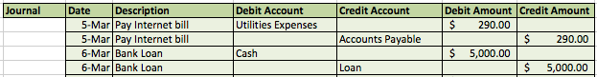

1. The **Journal** shows all of the double entries.
2. Each entry takes up two rows, hence the term double entry.
3. It includes the date of the entry, a brief description, the account that was debited, the account that was credited, and the amount of money.
4. Note: the amounts of money will be the same for debit and credit for each entry, as is standard accounting.

Income Sheet

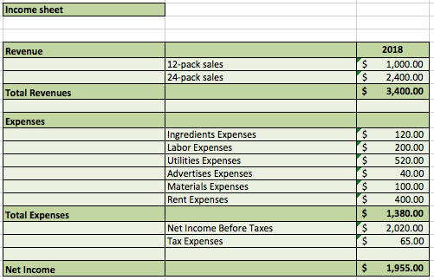

1. The **Income Sheet** shows the total revenue and expenses in a given time period.
2. It collects this information from entries marked ‘revenue’ and ‘expense’ in the **Journal.**
3. It calculates the **Net Income** bysubtracting the **Total Expenses** from the **Total Revenue**.

Balance Sheet

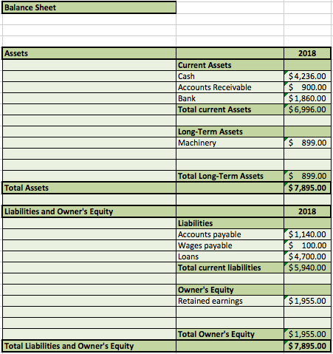

1. The **Balance Sheet** shows the value of each account, such as **Cash**, **Machinery**, **Loans**, etc.
2. Accounts are grouped into **Assets**, **Liabilities**, and **Owner’s Equity**, as is standard accounting practice.
3. The sum of **Total Assets** must always equal the sum of **Total Liability and Owner’s Equity**.
4. The **Assets** and **Liabilities** values are collected from the entries in the **Journal**.
5. The **Retained earnings** field pulls from the **Net Income** field in the **Income Sheet**.

Add entry button and Entry Row





1. The Add entry button enters a new double entry into the **Journal** section based on fields filled in the **Entry Row**.
2. All fields are required.
3. The **Debit Account** and **Credit Account** fields each contain a drop down list of permitted values.
4. Add entry will add two rows to the Journal section: a debit entry, and a credit entry.
5. Expenses are always debited, and revenues are always credited, per standard accounting practice.
6. Debits increase assets and decrease liabilities.
7. Credits decrease assets and increase liabilities.

Clear entry row button

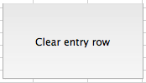



1. This returns the **Entry Row** to its default empty values.
2. It ensures the **Date** is today’s date.

Delete Last Entry button



1. This removes the bottom two rows of the **Journal** section.
2. Note: If the **Journal** has not yet been sorted by date, the bottom two rows contain the most recent entry.

Sort Journal button



1. This button sorts the **Journal** entries by date.
2. It displays a confirmation message upon finishing the sort.